11/7/2017

Find your stay!

!

**ACCOMODATION FINDER**

Team members:

* Naman Bansal (1MS15CS075)
* Prabhuling (1MS15CS090)
* P Suhas Rao (1MS15CS81)

**Ramaiah Institute of Technology**

**Abstract**

Objective:

To make it easier for the freshers coming from out of station to find the accommodation nearby college. They can search for the hostels/PG according to their requirements and contact the owner and make necessary arrangements.

If this app becomes popular, this will lead to increase in competition among the hostels and PGs which can lead to decrease in the prices of the hostels/PGs.

Description:This database will reduce the manual work of exploring the area and searching for the hostel/PGs according to the requirement of the new comers to the Locality. The database contains five entities. They are: Hostel, Area, Owner, Rooms, Mess. You can search for hostels economically and directly contact the owner. Compare different hostels and the facilities they provide. Different hostel/PGs owner can register their hostels and list all the facilities they provide along with the fees for different kind of rooms.

Scope:

If the project is successful in Mathikere, we will expand it to different localities.

**ER Diagram**

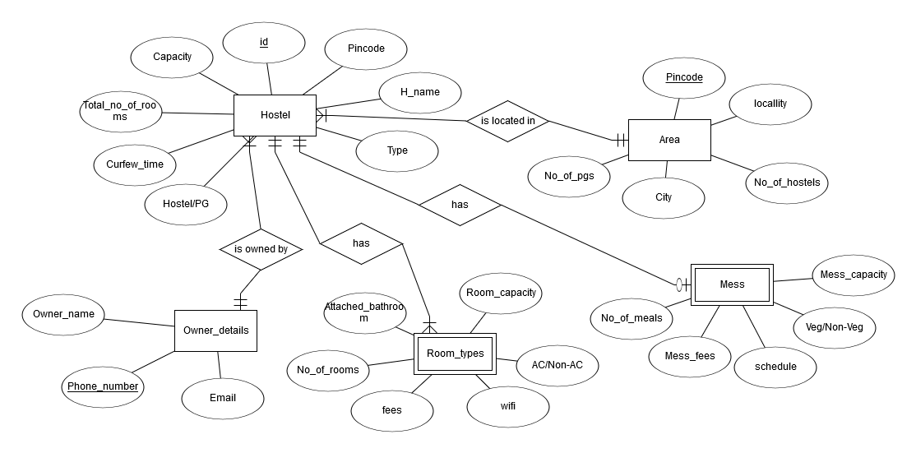

**Relational Schema**

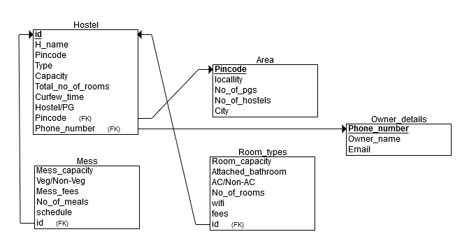

**Product Deliverables**

This product will make it easier to find proper accommodation in different areas according to their requirements. This will be especially beneficial to the college students who are in search of an accommodation. This will create a proper database of all the proper living accommodations nearby various institutes. This database will be helpful to the people coming from out of town, they won’t have to roam around in search for a proper accommodation.

Different owners can list their PG/Hostel on the website with complete specifications of rooms available. If the project is successful, it will lead to an increase in the competition and decrease in the prices of the Hostels/PGs.

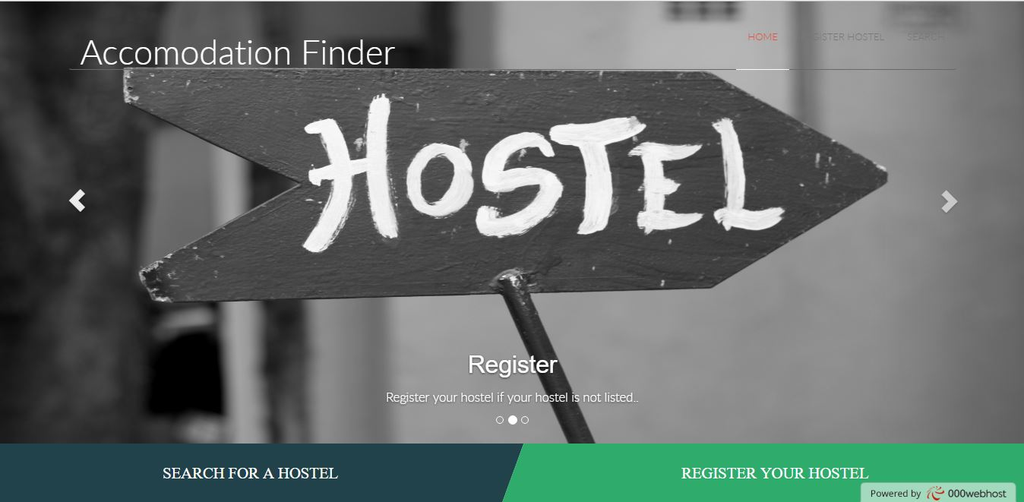**Snapshots**

